To complete form, click on each field with your mouse OR use tab or arrow keys. Space bar will select boxes. When completed, please email the form to your administrator .
VEHICLE REQUISITION FORM
PLEASE INDICATE IF YOU HAVE AN OLD VEHICLE FOR DISPOSAL.

 |  |  | DATE of REQUEST: | CLIENT:

DRIVER INFORMATION
DRIVER NAME (MAIN CONTACT IF POOLED VEHICLE) | HOME PHONE | CELL PHONE | EMAIL ADDRESS
ADDRESS | CITY |  | STATE | ZIP
DIVISION (select from dropdown menu)

VEHICLE REQUESTED
SPECIFY VEHICLE CHOICE (select from drop down menu):

COLOR SELECTION:  EXTERIOR:  INTERIOR: | IS THERE A PLATE TO TRANSER:  YES NO  IF YES, PLEASE SEND COPY OF CURRENT REGISTRATION  PLATE NUMBER:  EXPIRATION DATE:
ASIDE FROM STANDARD EQUIPMENT NORMALLY ON MODEL SELECTED, PLEASE LIST ADDITIONAL OPTIONS REQUESTED
a detail specification sheet can also be submitted with this request

ADDITIONAL COMMENTS:

Would you like CARITAS to sell an old vehicle? YES NO
If YES, please complete information below:
YEAR | MAKE | MODEL SEATING CAPACITY | CURRENT MILEAGE | VIN # (17 CHARACTERS LONG)
BRIEFLY DESCRIBE CONDITION OF VEHICLE:

CAN WE SELL NOW OR WHEN NEW VEHICLE IS DELIVERED?
NOW UPON NEW VEHICLE DELIVERY

FOR OFFICE COMPLETION ONLY
FACTORY ORDER OR STOCK BUY?
Factory order is typically recommended as it will be the lowest cost, but will take the most time for delivery. Dependent on model, delivery can be between 4-16 weeks.
Stock buy is for immediate need as vehicle is located off a dealer lot. Usually cost is higher due to overhead from dealer.

FACTORY ORDER STOCK BUY IF STOCK BUY, DATE NEW VEHICLE NEEDED:
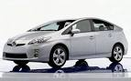

Toyota Prius 5 DR HB II (1223)

Standard and Company Provided Equipment:

1.8L DOHC I16 Valve 4Cyl Engine
Continuously Variable Transmission
STD Push Button Start
STD Traction Control
STD Front Wheel Drive
STD Traction Control
STD 15” 5-Spoke Aluminum Alloy Wheels
STD ABS Brakes
STD Dual Air Bags
STD Rear Deck Spoiler
STD Fog Lamps
STD Heated, Power Mirrors
STD Solar Tinted Glass
STD Intermittent Windshield Wipers
STD Intermittent Rear Wiper
STD Premium Cloth Front Bucket Seats
STD 6-Way Power Drivers Seat
STD 60/40 Split-Folding Rear Seat
STD Tilt/Telescopic Steering Wheel
STD Anti-Theft System
STD Cruise Control
STD Power Windows
STD Power Locks w/SmartKey System
STD Air Conditioning
STD Rear Window Defroster
STD AM/FM w/CD Player
STD Bluetooth Connectivity
CF Floor Mats

Miles Per Gallon estimates:
51 city
48 highway

Exterior Color Choices: Interior Choices:

2015 Exterior Colors

Black

Barcelona Red Metallic (not available with Misty Gray interior)

Classic Silver Metallic (not available with Bisque interior)

Nautical Blue Metallic

Sea Glass Pearl

Super White (not available with Misty Gray or Bisque interior)

Winter Gray Metallic (not available with Bisque interior)

Interiors:

Bisque

Dark Gray

Misty Gray

View colors at
http://www.toyota.com/prius-hybrid/exterior-360.html

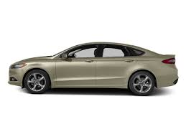

Ford Focus SE 4dr Sedan (P3F)

Standard and Company Provided Equipment:

99N 2.0 L DOHC I4 cylinder engine
44W2 6-Speed Automatic Transmission w/OD
STD Driver and Front Passenger Airbags
STD Front Side Side Airbags
STD Front Wheel Drive
STD 15” Steel Wheels
STD Power Mirrors
STD Tinted Glass
STD Intermittent Windshield Wipers
STD Front Cloth Reclining Bucket Seats
STD 60/40 Cloth Folding Rear Seat
STD 6-Way Driver Seat
STD Floor Console w/Floor Shifter
STD Floor Mats
STD Air Conditioning
STD Power Locks
STD Remote Keyless Entry
STD Power Windows
STD Electric Rear Window Defogger
STD AM/FM Stereo w/CD
STD Trip Computer w/ Outside Temperature
STD Tilt/Telescopic Steering Wheel
STD Cruise Control
STD Anti-lock Brakes w/Traction Control
STD SYNC Entertainment w/Bluetooth Connectivity
STD Rear Camera
STD Rear Parking Sensors

Miles Per Gallon estimates:
27 city
40 highway

Exterior Color Choices: Interior Choices

2016 Exterior Colors

Ingot Silver

Magnetic

Oxford White

Race Red (not available with Lt Stone interior)

Shadow Black

Tectonic

Interiors:

Charcoal Black

Medium Light Stone

View color choices at:
http://www.ford.com/cars/focus/

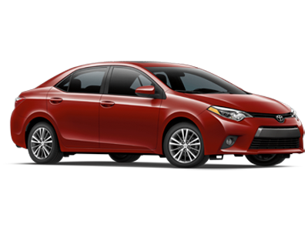

Toyota Corolla LE 4 Door Sedan (1852)

Standard and Order Provided Equipment:

1.8L Twin-Cam EFI 16-Valve 4- Cylinder Engine
4-Speed Automatic Transmission w/OD
STD Front wheel drive
STD Anti Lock Brakes
STD Driver and Front Passenger Airbags
STD Cloth reclining bucket seats
STD 6-way Manual Adjustable Driver Seat
STD 4-way Manual Adjustable Pssnger Seats
STD 60/40 split fold down rear seat
STD Daytime Running Lights
STD Tinted Glass
STD Intermittent Windshield Wipers
STD Dual Remote-Controlled Mirrors
STD Tilt Steering Wheel
STD HD Rear Window Defogger
STD Air Conditioning
STD Power Windows
STD Power Locks
STD Remote Keyless Entry
STD Cruise Control
STD AM/FM/CD Player w/6” Touch Screen
STD Bluetooth Wireless Technology
STD Rear Backup Camera
CF Carpeted Floor Mats

Miles Per Gallon estimates:
29 city

38 highway
Exterior Color Choices: Interior Choices

2016 Exterior Colors

4Evergreen Mica

Barcelona Red Metallic (not available with Amber interior)

Black Sand Mica

Brown Sugar Metallic (not available with Ash interior)

Classic Silver Metallic (not available with Ivory or Amber interior)

Slate Metallic

Super White

Interiors:

Amber

Ash

Ivory

View color choices at: http://www.toyota.com/corolla/color.html

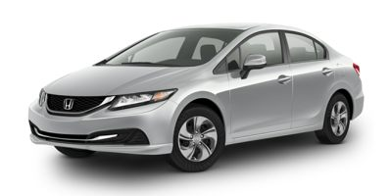

Honda Civic 4 Door LX Sedan (FB2F5FEW)

Standard and Order Provided Equipment:

1.8L SOHC 16-Valve 4-Cylinder Engine
4-Speed CVT Transmission
STD Front wheel drive
STD Anti Lock Brakes
STD Driver and Front Passenger Airbags
STD Cloth reclining bucket seats
STD 6-way Manual Adjustable Driver Seat
STD 4-way Manual Adjustable Pssnger Seats
STD Tinted Glass
STD Intermittent Windshield Wipers
STD Dual Remote-Controlled Mirrors
STD Tilt Steering Wheel
STD Rear Window Defogger
STD Air Conditioning
STD Power Windows
STD Power Locks
STD Remote Keyless Entry
STD Cruise Control
STD AM/FM/CD Player w/USB interface
STD Bluetooth Wireless Technology
STD Rear Backup Camera
STD Carpeted Floor Mats

Miles Per Gallon estimates:
30 city

39 highway

Exterior Color Choices: Interior Choices

2015 Exterior Colors

Alabaster Silver Metallic (not available with Beige interior)

Crimson Pearl (not available with Gray or Black interior)

Crystal Black Pearl (not available with Beige interior)

Dyno Blue Pearl (not available with Beige or Black interior)

Modern Steel Metallic (not available with Beige interior)

Taffeta White (not available with Gray or Black interior)

Urban Titanium Metallic (not available with Gray or Black interior)

Interiors:

Beige

Black

Gray

